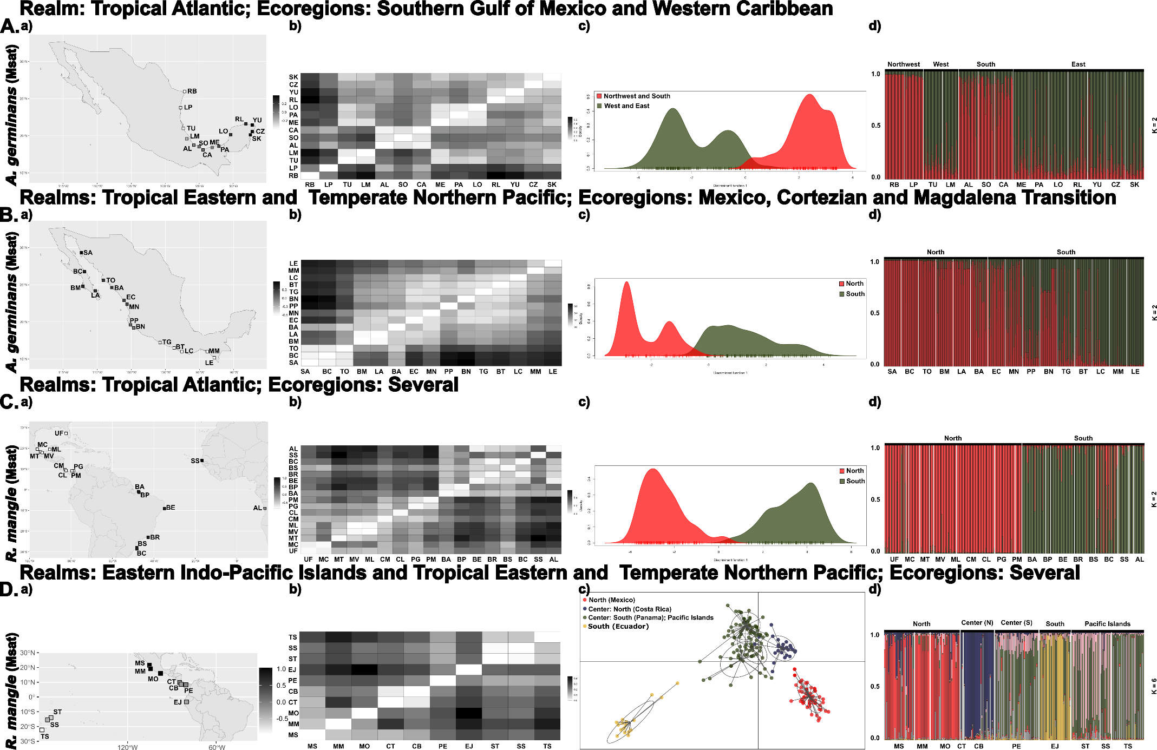
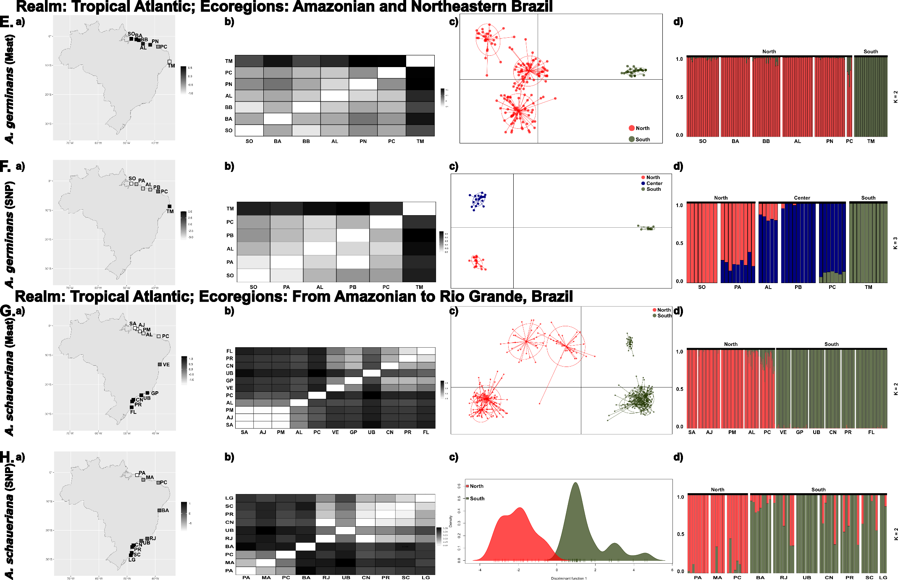
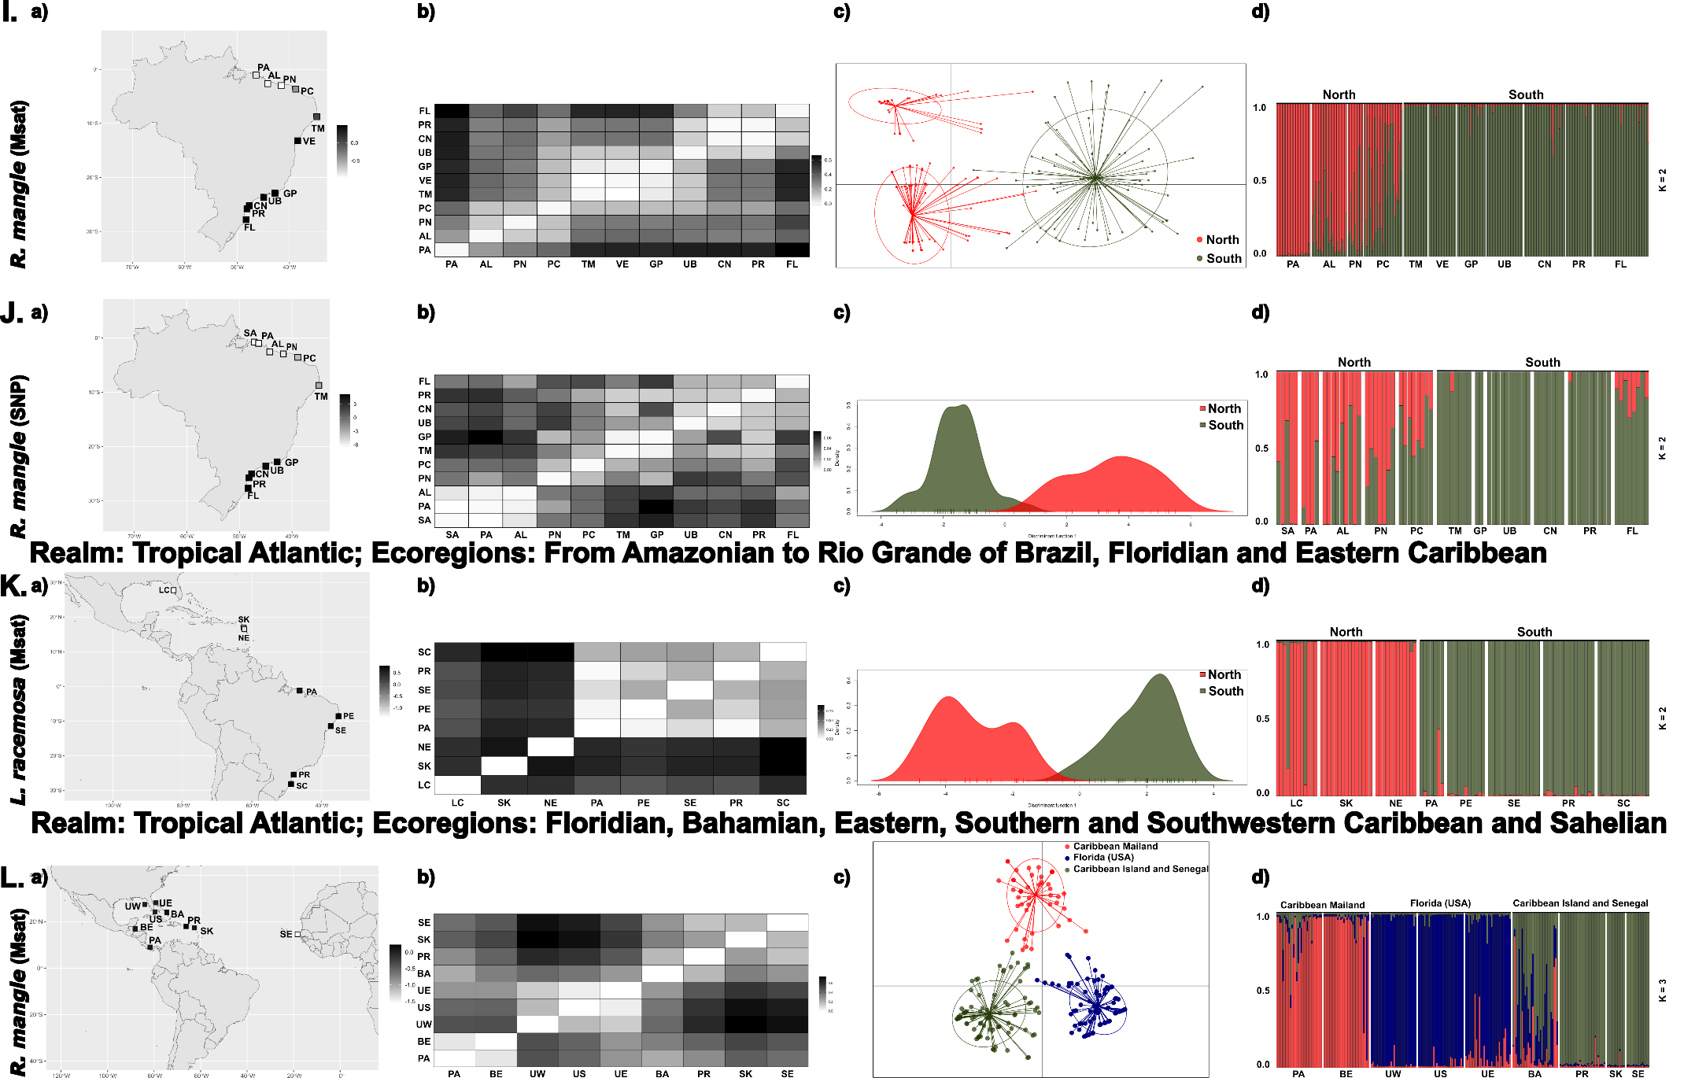
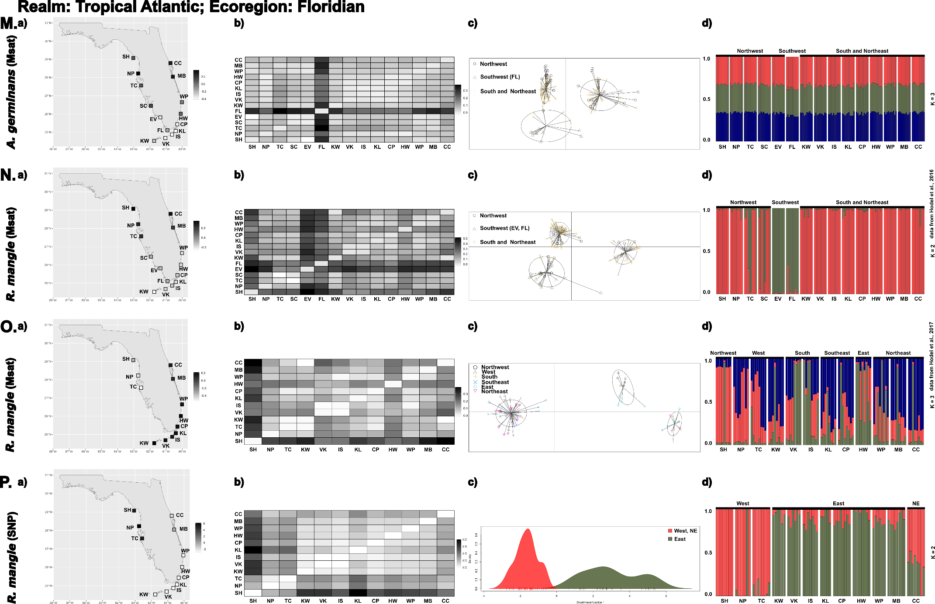
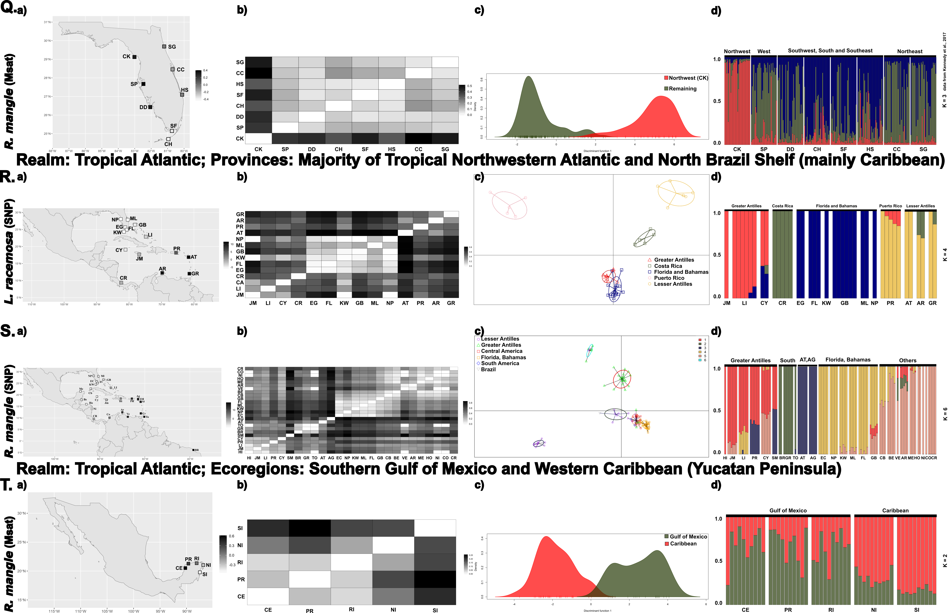
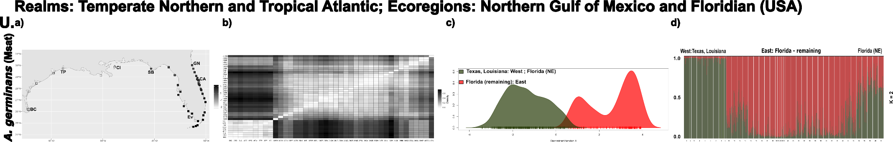
Figure S1. Population genetic structure of all (re)analyzed datasets (From A to U). For each dataset, the following are reported: Realms, Ecoregions or Provinces (according to Spalding et al., 2007), species and genetic marker (the origin of the data is informed, if the information coincide). From right to left, the following are shown - a) spatial PCA (sPCA), b) pairwise F_{ST}, c) Discriminant Analysis of Principal Components (DAPC) and d) methods based on genetic models (STRUCTURE for microsatellite data and ADMIXTURE for SNP data). Sampling site acronyms can be found in the original paper.

References according to the order of the figure
A. and B. Ochoa-Zavala, M., Jaramillo-Correa, J. P., Piñero, D., Nettel-Hernanz, A., & Núñez-Farfán, J. (2019). Contrasting colonization patterns of black mangrove (Avicennia germinans (L.) L.) gene pools along the Mexican coasts. Journal of Biogeography, 46(5), 884–898. https://doi.org/10.1111/jbi.13536
C. and D. and DTakayama, K., Tamura, M., Tateishi, Y., Webb, E. L., & Kajita, T. (2013). Strong genetic structure over the American continents and transoceanic dispersal in the mangrove genus Rhizophora (Rhizophoraceae) revealed by broad- scale nuclear and chloroplast DNA analysis. American Journal of Botany, 100(6), 1191–1201. https://doi.org/10.3732/ajb.1200567
E. Mori, G. M., Zucchi, M. I., & Souza, A. P. (2015). Multiple-geographic-scale genetic structure of two mangrove tree species: The roles of mating system, hybridization, limited dispersal and extrinsic factors. PLoS ONE, 10(2), 1–23. https://doi.org/10.1371/journal.pone.0118710
F. Cruz, M. V., Mori, G. M., Oh, D. H., Dassanayake, M., Zucchi, M. I., Oliveira, R. S., & Souza, A. P. de. (2020). Molecular responses to freshwater limitation in the mangrove tree Avicennia germinans (Acanthaceae). Molecular Ecology, 29(2), 344–362. https://doi.org/10.1111/mec.15330
G. Mori, G. M., Zucchi, M. I., & Souza, A. P. (2015). Multiple-geographic-scale genetic structure of two mangrove tree species: The roles of mating system, hybridization, limited dispersal and extrinsic factors. PLoS ONE, 10(2), 1–23. https://doi.org/10.1371/journal.pone.0118710
H. Cruz, M. V., Mori, G. M., Signori-Müller, C., da Silva, C. C., Oh, D. H., Dassanayake, M., Zucchi, M. I., Oliveira, R. S., & de Souza, A. P. (2019). Local adaptation of a dominant coastal tree to freshwater availability and solar radiation suggested by genomic and ecophysiological approaches. Scientific Reports, 9(1), 1–15. https://doi.org/10.1038/s41598-019-56469-w
I. Francisco, P. M., Mori, G. M., Alves, F. M., Tambarussi, E. V., & de Souza, A. P. (2018). Population genetic structure, introgression, and hybridization in the genus Rhizophora along the Brazilian coast. Ecology and Evolution, 8(6), 3491–3504. https://doi.org/10.1002/ece3.3900
J. Madeira, A. G., Tsuda, Y., Nagano, Y., Iwasaki, T., Zucchi, M. I., Kajita, T., & Mori, G. M. (2023). The role of oceanic currents in the dispersal and connectivity of the mangrove Rhizophora mangle on the Southwest Atlantic region. Molecular Ecology Resources. https://doi.org/10.1111/1755-0998.13807
K. Sereneski-Lima, C., Baggio, R. A., Pil, M. W., Torres Boeger, M. R., & Boeger, W. A. (2021). Historical and contemporary factors affect the genetic diversity and structure of Laguncularia racemosa (L.) Gaertn, along the western Atlantic coast. Estuarine, Coastal and Shelf Science, 249(September 2019), 107055. https://doi.org/10.1016/j.ecss.2020.107055
L. Kennedy, J. P., Pil, M. W., Proffi, C. E., Boeger, W. A., Stanford, A. M., & Devlin, D. J. (2016). Postglacial expansion pathways of red mangrove , Rhizophora mangle , in the Caribbean Basin and Florida 1. 103(2), 260–276. https://doi.org/10.3732/ajb.1500183
M. and N. Hodel, R. G. J., De Souza Cortez, M. B., Soltis, P. S., & Soltis, D. E. (2016). Comparative phylogeography of black mangroves (Avicennia germinans) and red mangroves (Rhizophora mangle) in Florida: Testing the maritime discontinuity in coastal plants. American Journal of Botany, 103(4), 730–739. https://doi.org/10.3732/ajb.1500260
O. and P. Hodel, R. G. J., Chen, S., Payton, A. C., Mcdaniel, S. F., Soltis, P., & Soltis, D. E. (2017). Adding loci improves phylogeographic resolution in red mangroves despite increased missing data : comparing microsatellites and RAD-Seq and investigating loci filtering. Scientific Reports, November, 1–14. https://doi.org/10.1038/s41598-017-16810-7
Q. Kennedy, J. P., Garavelli, L., Truelove, N. K., Devlin, D. J., Box, S. J., Ch, L. M., & Feller, I. C. (2017). Contrasting genetic effects of red mangrove ( Rhizophora mangle L .) range expansion along West and East Florida. 335–347. https://doi.org/10.1111/jbi.12813
R. and S. Hodel, R. G. J., Knowles, L. L., McDaniel, S. F., Payton, A. C., Dunaway, J. F., Soltis, P. S., & Soltis, D. E. (2018). Terrestrial species adapted to sea dispersal: Differences in propagule dispersal of two Caribbean mangroves. Molecular Ecology, 27(22), 4612–4626. https://doi.org/10.1111/mec.14894
T. Cisneros‐de la Cruz, D. J., Martínez‐Castillo, J., Herrera‐Silveira, J., Yáñez‐Espinosa, L., Ortiz‐García, M., Us‐Santamaria, R., & Andrade, J. L. (2018). Short‐distance barriers affect genetic variability of Rhizophora mangle L. in the Yucatan Peninsula. Ecology and Evolution, 8(22), 11083–11099. https://doi.org/10.1002/ece3.4575
U. Kennedy, J. P., Preziosi, R. F., Rowntree, J. K., & Feller, I. C. (2020). Is the central-marginal hypothesis a general rule? Evidence from three distributions of an expanding mangrove species, Avicennia germinans (L.) L. Molecular Ecology, 29(4), 704–719. https://doi.org/10.1111/mec.15365
Realms, ecoregions or provinces according to
Spalding, M. D., Fox, H. E., Allen, G. R., Davidson, N., Ferdaña, Z. A., Finlayson, M., Halpern, B. S., Jorge, M. A., Lombana, A., Lourie, S. A., Martin, K. D., McManus, E., Molnar, J., Recchia, C. A., & Robertson, J. (2007). Marine ecoregions of the world: A bioregionalization of coastal and shelf areas. BioScience, 57(7), 573–583. https://doi.org/10.1641/B570707

